3 Steps to Perform SSH Login Without Password Using ssh-keygen

System1 system2

1. install sssh

2 cd .ssh/
ssh-keygen
enter all thing

3.the public key content idrsapub to system to rename as authorized_keys
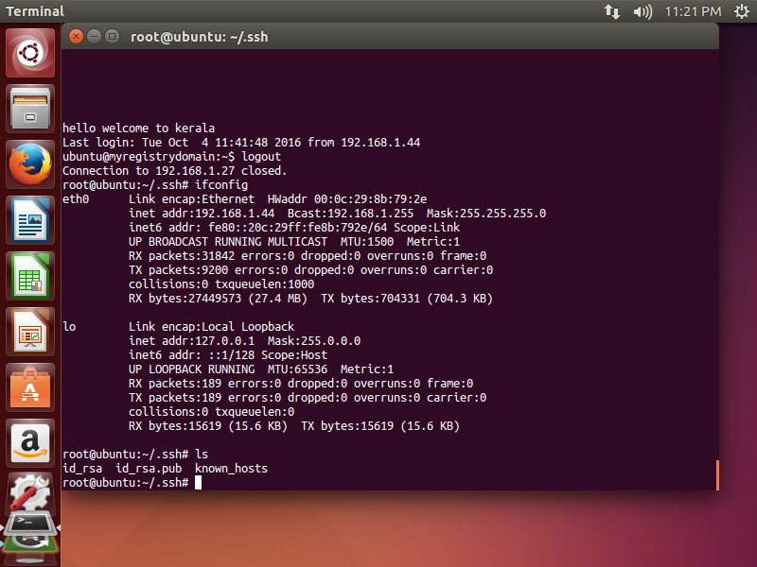
copy contents or scp

